Even Functions:
A function is "even" when f(x) = f(−x) for all x
In other words there is symmetry about the y-axis .

This is the curve f(x) = x²+1
They got called "even" functions because the functions x², x⁴, x⁶, x⁸, etc behave like that, but there are other functions that behave like that too, such as cos(x):
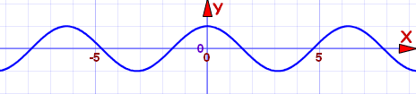
Cosine function: f(x) = cos(x)
It is an even function

Odd Functions:
A function is "odd" when −f(x) = f(−x) for all x
And we get origin symmetry:

This is the curve f(x) = x³−x
They got called "odd" because the functions x, x³, x⁵, x⁷, etc behave like that, but there are other functions that behave like that, too, such as sin(x):
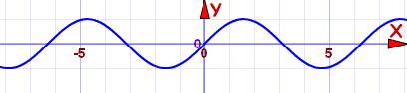
Sine function: f(x) = sin(x)
It is an odd function

